**Regular Expressions**

**Characters**

* Escape character: \
* Any character: .
* Digit: \d
* Not a digit: \D
* Word character: \w
* Not a word character: \W
* Whitespace: \s
* Not whitespace: \S
* Word boundary: \b
* Not a word boundary: \B
* Beginning of a string: ^
* End of a string: $

**Groupings**

* Matches characters in brackets: [ ]
* Matches characters not in brackets: [^ ]
* Either or: |
* Capturing group: ( )

**Quantifiers**

* 0 or more: *
* 1 or more: +
* 0 or 1: ?
* An exact number of characters: { }
* Range of number of characters: {Minimum, Maximum}

**תרגיל 1**

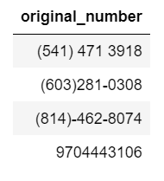

**תרגיל 2**

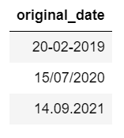

**תרגיל 3**

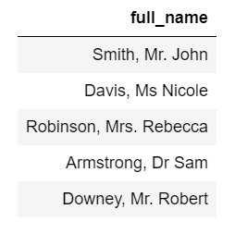

**תרגיל 4**

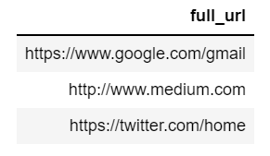

**תרגיל 5**

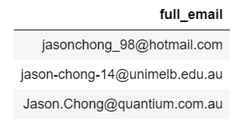

**תרגיל 6**

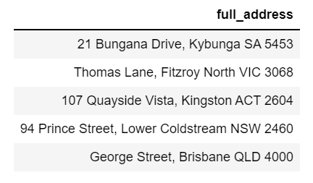

**פתרונות**

* 1. phone_pattern = ".?(\\d{3}).*(\\d{3}).*(\\d{4})"
  2. date_pattern = "(\\d{2}).(\\d{2}).(\\d{4})"
  3. name_pattern = "(\\w+),\\s(Mr|Ms|Mrs|Dr).?\\s(\\w+)"
  4. url_pattern = "(https?)://(www)?.?(\\w+).(\\w+)/?(\\w+).(\\w+)/%3f(\\w+))?"
  5. email_pattern = "([a-zA-Z0-9\\_\\-\\.]+)@([a-zA-Z]+).(.+)"
  6. address_pattern = "(\\d*)\\s?(.+),\\s(.+)\\s([A-Z]{2,3})\\s(\\d{4}\\s%3f(.+),\\s(.+)\\s(%5bA-Z%5d%7b2,3%7d)\\s(\\d%7b4%7d))"

for more information:

<https://towardsdatascience.com/regular-expressions-clearly-explained-with-examples-822d76b037b4>